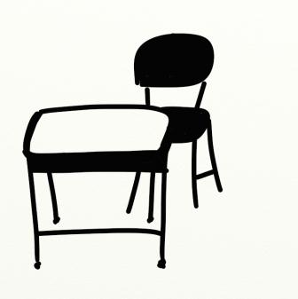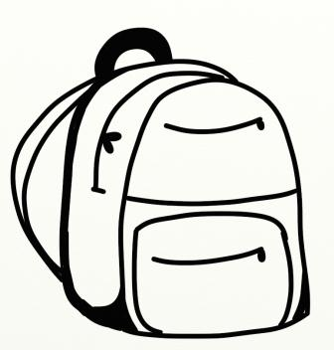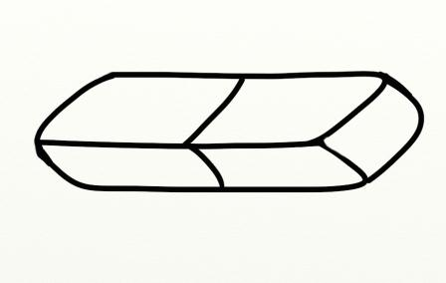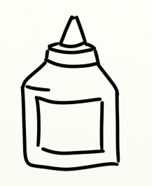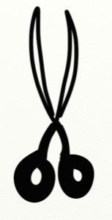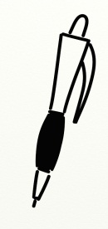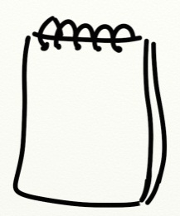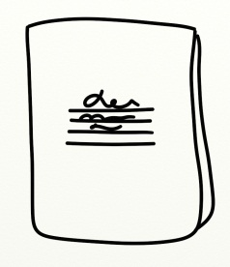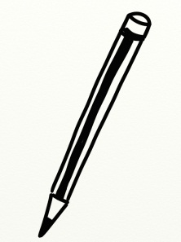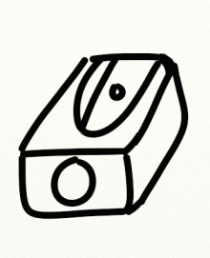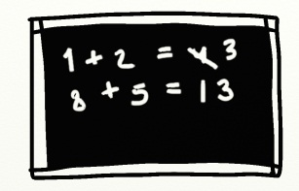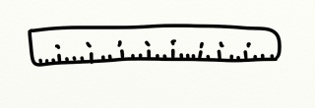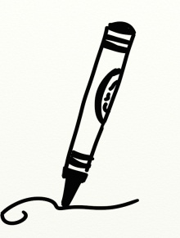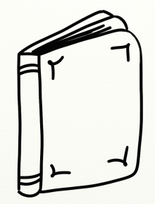
V osmisměrce najdi 9 školních potřeb:
1
2
3
4
5
6
7
8
9
S | H | A | R | P | E | N | E | R | A
C | E | G | A | D | E | S | K | R | P
I | D | L | O | K | S | Y | P | U | E
S | S | U | P | R | I | P | S | L | N
S | O | E | R | A | S | E | R | E | C
O | D | N | V | S | O | N | A | R | I
R | E | A | B | E | B | O | O | K | L
S | C | R | A | Y | O | N | K | E | R

5
2
1
13
9
10
4
__ DESK
__ PENCIL
__ RUBBER
__ SCHOOL BAG
_14_ EXERCISE BOOK
_4_ NOTEBOOK
_11_ SHARPENER
14
12
11
8
3
7
6
- Spoj slovíčka s obrázky:
SCHOOL THINGS

RULER __
BOOK __
PEN __
GLUE __
BOARD __
CRAYON _7_
SCISSORS __

